05th October 2026

Internship Experience Certificate

This is to certify that Mr. Kishore Kumar L (Reg.No: 44734015), M.Sc., (Computer Science) student of Sathyabama University, Chennai has done internship at Gradtwin Services from May 2026 to July 2026 in the platform of Data Science Domain.
We have found him to be a self-starter who is motivated, duty bound and Hard-working. He worked sincerely on his assignments and his performance was Par Excellence.
We are proud to have had Mr. Kishore Kumar L as part of our team and wish him continued success in his future endeavours. We wish him the best for his future.

For Gradtwin Services (OPC) Private Limited
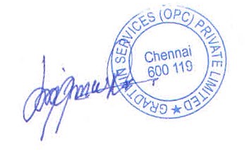

Kanishrajiah Durairaju

Manager - Human Resource

